23CSE202 DATABASE MANAGEMENT SYSTEMS
S3 B.Tech CSE
Department of Computer Science and Engineering
Amrita School of Computing, Amritapuri Campus

3. Database Design Document

Group No : D3
Team Members :
Roll No | Student Name
AM.SC.U4CSE25302 | Anandanarayan P
AM.SCU4CSE25312 | Devanandana C
AM.SC.U4CSE25313 | Devang S R
AM.SC.U4CSE25327 | Kasinath K S

Project Title : Hotel Management System

3.1. Detailed description of the project:
“Guests book rooms online. Each guest has a guest_id ,name, idProof and
Phone number.Guest can requests service via app.
Each Service has a service Id , service type(food/room) and price. and can only by a Receptionist(admin).Services are a provideed by Admins.
Each Admin has an adminId , name, password,type(Receptionist and and specific features for their specific profile.
Guests books room. Each booking has a booking no, checkInDate ,checkOutDate .Bookings are managed by admins and generate bills for each booking.
A booking can reserve multiple rooms.Each room has a room number, room type, price, availability.”

3.2. ER Diagram
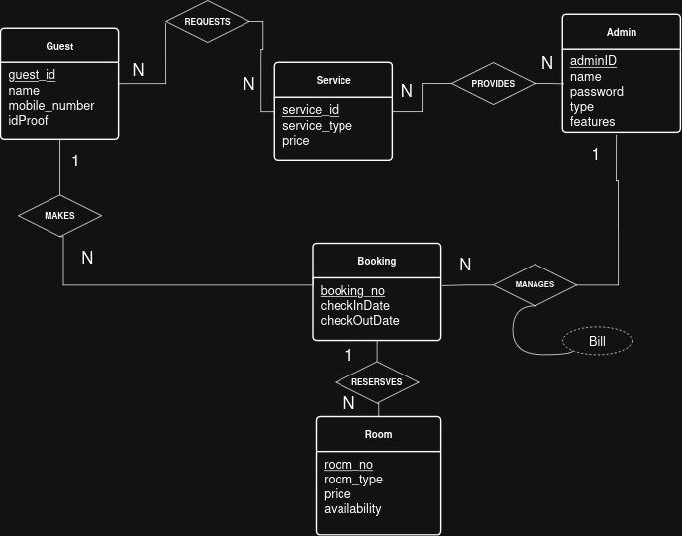

3.3 Relational Schema
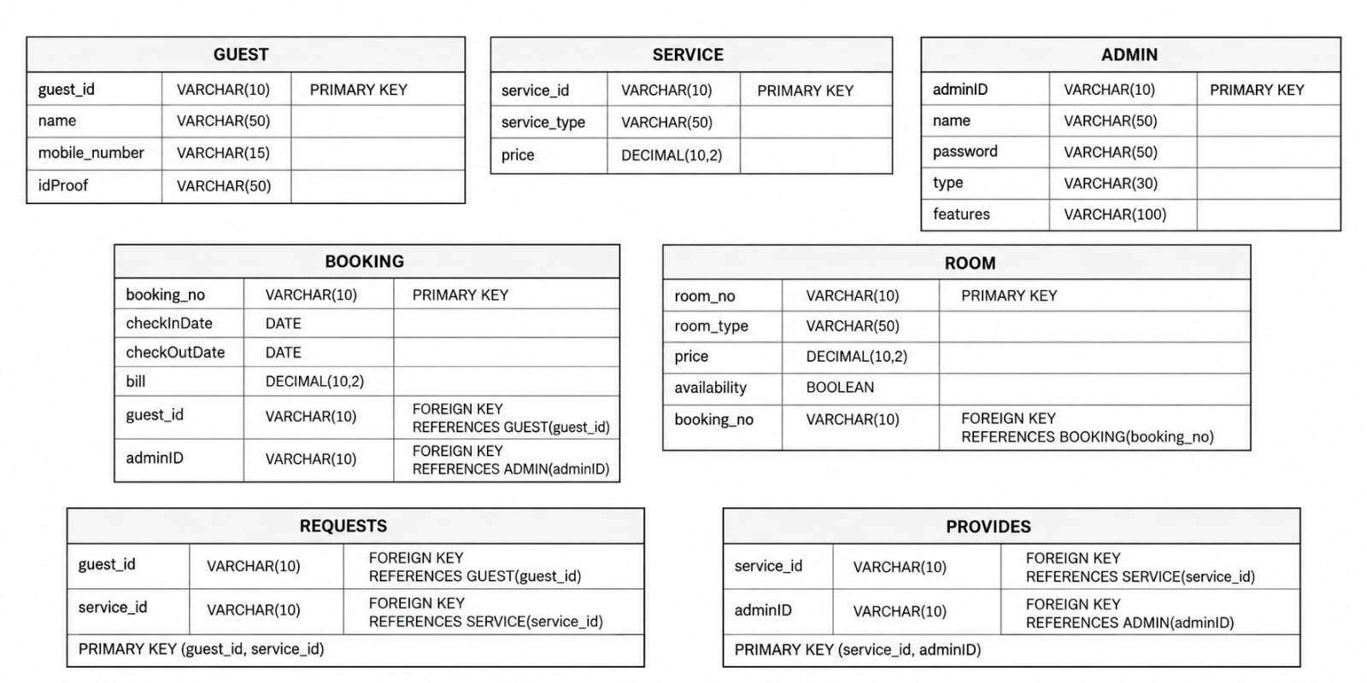

3.4 Normalization and Functional dependency analysis
Normalization Process Starting from 1NF to BCNF
- Admin Table
admin_ID | name | password | type | feature
R100 | Alice | pass123 | Receptionist | check in guest, checkout guest, retrieve Booking, initiate service
M100 | Bob | pass456 | Manager | generate reports, generate bill, retrieve Booking, view occupancy

First Normal Form (1NF)
adminID | name | password | type | feature
R100 | Alice | pass123 | Receptionist | check In Guest
R100 | Alice | pass123 | Receptionist | Check Out Guest
R100 | Alice | pass123 | Receptionist | Initiate Service
R100 | Alice | pass123 | Receptionist | retrieve Booking
M100 | Bob | pass456 | Manager | Generate Report
M100 | Bob | pass456 | Manager | Generate Bill
M100 | Bob | pass456 | Manager | retrieve Booking
M100 | Bob | pass456 | Manager | view Occupancy
R100 | Alice | pass123 | Receptionist | view Occupancy
Primary Key: (admin_id)
Functional dependencies: admin_id → name,password,type,features;
type → features

Second Normal Form (2NF)
No partial dependency, So already in 2NF.

Third Normal Form (3NF)
admin_ID | name | password | Type
R100 | Alice | pass123 | Receptionist
M100 | Bob | pass456 | Manager
Table 1: Admin Details

Functional dependencies: admin_id → name,password,type,features;

Table 2: Admin Features
Type | Feature
Receptionist | check In Guest
Receptionist | Check Out Guest
Receptionist | Initiate Service
Receptionist | retrieve Booking
Receptionist | view Occupancy
Manager | retrieve Booking
Manager | view Occupancy
Manager | Generate Report
Manager | Generate Bill
Functional dependencies:type → features

Boyce-Codd Normal Form (BCNF)
“The primary key is admin_ID in Admin_details relation. The functional dependency is admin_ID -> {name, password, type}. Since admin_ID is the primary key (and therefore a superkey), this table satisfies BCNF. ”

“The primary key is {type,features} in Admin_features relation. Since {type,features} is the primary key (and therefore a superkey), this table satisfies BCNF.”

- Booking Table

First Normal Form

BOOKING — 1NF
All attributes contain atomic values. Since one booking may reserve multiple rooms, each booking-room combination is represented as a separate row.

booking_no | checkInDate | checkOutDate | guest_id | adminID | room_no
B1001 | 10-09-2026 | 15-09-2026 | G1001 | R100 | 101
B1001 | 10-09-2026 | 15-09-2026 | G1001 | R100 | 102
B1002 | 12-09-2026 | 16-09-2026 | G1002 | R101 | 103
B1003 | 14-09-2026 | 18-09-2026 | G1003 | R101 | 104

Primary Key: (booking_no, room_no)
Functional dependencies: booking_no → checkInDate, checkOutDate, guest_id, adminID; room_no → room_type, price, availability.

Second Normal Form

BOOKING / BOOKING_ROOM
The composite key in 1NF causes partial dependencies. Booking details depend only on booking_no, while room details depend only on room_no. Therefore, the relation is decomposed.
booking_no | checkInDate | checkOutDate |  | guest_id | adminID
B1001 | 10-09-2026 | 15-09-2026 |  | G1001 | R100
B1002 | 12-09-2026 | 16-09-2026 |  | G1002 | R101
B1003 | 14-09-2026 | 18-09-2026 |  | G1003 | R101
 | booking_no |  | room_no
 | B1001 |  | 101
 | B1001 |  | 102
 | B1002 |  | 103
 | B1003 |  | 104

Result: Partial dependencies are removed. The relations are now in 2NF.

Third Normal Form

BOOKING / BOOKING_ROOM
Already in 3NF
booking_no | checkInDate | checkOutDate | guest_id | adminID
B1001 | 10-09-2026 | 15-09-2026 | G1001 | R100
B1002 | 12-09-2026 | 16-09-2026 | G1002 | R101
B1003 | 14-09-2026 | 18-09-2026 | G1003 | R101
BOOKING

BOOKING_ROOM
booking_no | room_no
B1001 | 101
B1001 | 102
B1002 | 103
Result: No transitive dependency remains. The schema is in 3NF.

- Guest Table

First Normal Form (1NF)
Example: Hithesh (G1001) has three phone numbers. A cell containing multiple phone numbers would violate 1NF. Each phone number is therefore stored as an atomic value in a separate row.
guest_id | guest_name | mobile_number | idProof
G1001 | Hithesh | 9000001001 | IDP1001
G1001 | Hithesh | 9000001002 | IDP1001
G1001 | Hithesh | 9000001003 | IDP1001
G1002 | Reshmi | 9000001004 | IDP1002
G1003 | George | 9000001005 | IDP1003
G1004 | Hari | 9000001006 | IDP1004
G1005 | Sahal | 9000001007 | IDP1005
G1006 | Anusree | 9000001008 | IDP1006
G1007 | Niroop | 9000001009 | IDP1007
G1008 | Satheesh | 9000001010 | IDP1008

1NF Relation: Guest(guest_id, guest_name, mobile_number, idProof)
Primary Key: (guest_id, mobile_number)

Second Normal Form (2NF)
Problem: The 1NF key is composite: (guest_id, mobile_number). guest_name and idProof depend only on guest_id. This is a partial dependency.
Decomposition:
GUEST
guest_id | guest_name | idProof
G1001 | Hithesh | IDP1001
G1002 | Reshmi | IDP1002
G1005 | Sahal | IDP1005
G1008 | Satheesh | IDP1008

GUEST_PHONE
guest_id | mobile_number
G1001 | 9000001001
G1001 | 9000001002
G1001 | 9000001003
G1002 | 9000001004
G1003 | 9000001005
G1004 | 9000001006
G1005 | 9000001007
G1006 | 9000001008
G1007 | 9000001009
G1008 | 9000001010

Result: Partial dependency is removed. The relations are in 2NF.

Third Normal Form (3NF)
Requirement: Be in 2NF and have no transitive dependency. In the decomposed relations, guest details depend directly on guest_id, and GUEST_PHONE contains only its key attributes.

GUEST
guest_id | guest_name | idProof
G1001 | Hithesh | IDP1001
G1002 | Reshmi | IDP1002
G1005 | Sahal | IDP1005
G1008 | Satheesh | IDP1008

GUEST_PHONE
guest_id | mobile_number
G1001 | 9000001001
G1001 | 9000001002
G1001 | 9000001003
G1002 | 9000001004
G1003 | 9000001005
G1004 | 9000001006
G1005 | 9000001007
G1006 | 9000001008
G1007 | 9000001009
G1008 | 9000001010
Result: No transitive dependency exists. Therefore the relations are in 3NF.

Boyce-Codd Normal Form (BCNF)
Requirement: For every non-trivial functional dependency X → Y, X must be a superkey.

GUEST
guest_id | guest_name | idProof
G1001 | Hithesh | IDP1001
G1002 | Reshmi | IDP1002
G1005 | Sahal | IDP1005
G1008 | Satheesh | IDP1008
Functional dependency: guest_id → guest_name, idProof. guest_id is the primary key and therefore a superkey.

GUEST_PHONE
guest_id | mobile_number
G1001 | 9000001001
G1001 | 9000001002
G1001 | 9000001003
G1002 | 9000001004
G1003 | 9000001005
G1004 | 9000001006
G1005 | 9000001007
G1006 | 9000001008
G1007 | 9000001009
G1008 | 9000001010
The key is (guest_id, mobile_number); there are no non-key attributes. Thus it satisfies BCNF.
Final Result: With multiple phone numbers for one guest, 1NF uses atomic phone values, and decomposition into GUEST and GUEST_PHONE gives 2NF, 3NF and BCNF.
Phone numbers and ID proofs are fictional sample values.

Services table

First Normal Form (1NF)
Each request contains attributes for guest, service, and admin details. Storing all attributes in a single table without partial or transitive dependency resolution represents 1NF.

guest_id | request_id | service_id | service_type | price | admin_id
G1001 | SR1001 | S101 | Food Service | 300 | R100
G1002 | SR1002 | S102 | Room Cleaning | 200 | R101
G1003 | SR1003 | S102 | Room Cleaning | 200 | R101
G1004 | SR1004 | S103 | Extra Bed | 400 | R102
G1005 | SR1005 | S101 | Food Service | 300 | R100
G1006 | SR1006 | S101 | Food Service | 300 | R100
G1007 | SR1007 | S103 | Extra Bed | 400 | R102
G1008 | SR1008 | S104 | Facility Repair | 0 | R103

1NF Relation: ServiceRequest(guest_id, guest_name, request_id, service_id, service_type, price, admin_id, admin_name)
Primary Key: request_id

Second Normal Form (2NF)
Problem: The non-key attributes service_type and price depend on service_id. The schema is decomposed into distinct entities to address functional dependencies.
Decomposition:

SERVICE
service_id | service_type | price
S101 | Food Service | 300
S102 | Room Cleaning | 200
S103 | Extra Bed | 400
S104 | Facility Repair | 0

SERVICE REQUEST
request_id | service_id | guest_id | admin_id
SR1001 | S101 | G1001 | R100
SR1002 | S102 | G1002 | R101
SR1003 | S102 | G1003 | R101
SR1004 | S103 | G1004 | R102
SR1005 | S101 | G1005 | R100
SR1006 | S101 | G1006 | R100
SR1007 | S103 | G1007 | R102
SR1008 | S104 | G1008 | R103

Result: Partial and direct dependencies for service_id are separated into the SERVICE table. The relations are in 2NF.

Third Normal Form (3NF)
Requirement: Be in 2NF and have no transitive dependencies. Non-key attributes guest_name and admin_name are extracted into dedicated primary entities GUEST and ADMIN.

SERVICE
service_id | service_type | price
S101 | Food Service | 300
S102 | Room Cleaning | 200
S103 | Extra Bed | 400
S104 | Facility Repair | 0

SERVICE REQUEST
request_id | service_id | guest_id | admin_id
SR1001 | S101 | G1001 | R100
SR1002 | S102 | G1002 | R101
SR1003 | S102 | G1003 | R101
SR1004 | S103 | G1004 | R102
SR1005 | S101 | G1005 | R100
SR1006 | S101 | G1006 | R100
SR1007 | S103 | G1007 | R102
SR1008 | S104 | G1008 | R103

Boyce-Codd Normal Form (BCNF)
Requirement: For every non-trivial functional dependency X → Y, X must be a superkey.

SERVICE
Functional dependency: service_id → service_type, price. service_id is the primary key and therefore a superkey.
service_id | service_type | price
S101 | Food Service | 300
S102 | Room Cleaning | 200
S103 | Extra Bed | 400
S104 | Facility Repair | 0

SERVICE REQUEST
Functional dependency: request_id → service_id, guest_id, admin_id. request_id is the primary key and therefore a superkey.
request_id | service_id | guest_id | admin_id
SR1001 | S101 | G1001 | R100
SR1002 | S102 | G1002 | R101
SR1003 | S102 | G1003 | R101
SR1004 | S103 | G1004 | R102
SR1005 | S101 | G1005 | R100
SR1006 | S101 | G1006 | R100
SR1007 | S103 | G1007 | R102
SR1008 | S104 | G1008 | R103

Final Result: The relations satisfy BCNF because all determinant attributes across SERVICE and SERVICE REQUEST serve as superkeys.

Room table

First Normal Form (1NF)
Each room record contains the attributes room_number, room_type, price, and availability. Storing all attributes in a single table without partial or transitive dependency resolution represents 1NF.
room_number | room_type | price | availability
R201 | Deluxe | 3500 | Available
R202 | Standard | 2000 | Available
R203 | Deluxe | 3500 | Booked
R204 | Suite | 6000 | Available
R205 | Standard | 2000 | Booked
R206 | Deluxe | 3500 | Available
R207 | Suite | 6000 | Booked
R208 | Standard | 2000 | Available
R209 | Deluxe | 3500 | Booked
R210 | Suite | 6000 | Available
R211 | Standard | 2000 | Available
R212 | Deluxe | 3500 | Booked
1NF Relation: Room(room_number, room_type, price, availability)
Primary Key: room_number

Second Normal Form (2NF)
Problem: The non-key attribute price depends on room_type rather than directly and independently on room_number. The schema is decomposed into distinct entities to address this functional dependency.
Decomposition:
ROOM_TYPE
room_type | price
Standard | 2000
Deluxe | 3500
Suite | 6000
ROOM
room_number | room_type | availability
R201 | Deluxe | Available
R202 | Standard | Available
R203 | Deluxe | Booked
R204 | Suite | Available
R205 | Standard | Booked
R206 | Deluxe | Available
R207 | Suite | Booked
R208 | Standard | Available
R209 | Deluxe | Booked
R210 | Suite | Available
R211 | Standard | Available
R212 | Deluxe | Booked
Result: The dependency of price on room_type is separated into the ROOM_TYPE table. The relations are in 2NF.

Third Normal Form (3NF)
Requirement: Be in 2NF and have no transitive dependencies. In the ROOM table, room_type and availability depend directly on room_number. In the ROOM_TYPE table, price depends directly on room_type. No non-key attribute depends on another non-key attribute, so no further decomposition is required.
ROOM_TYPE
room_type | price
Standard | 2000
Deluxe | 3500
Suite | 6000
ROOM
room_number | room_type | availability
R201 | Deluxe | Available
R202 | Standard | Available
R203 | Deluxe | Booked
R204 | Suite | Available
R205 | Standard | Booked
R206 | Deluxe | Available
R207 | Suite | Booked
R208 | Standard | Available
R209 | Deluxe | Booked
R210 | Suite | Available
R211 | Standard | Available
R212 | Deluxe | Booked
Result: No transitive dependencies exist. Therefore the relations are in 3NF.

Boyce-Codd Normal Form (BCNF)
Requirement: For every non-trivial functional dependency X → Y, X must be a superkey.
ROOM
Functional dependency: room_number → room_type, availability. room_number is the primary key and therefore a superkey.
room_number | room_type | availability
R201 | Deluxe | Available
R202 | Standard | Available
R203 | Deluxe | Booked
R204 | Suite | Available
R205 | Standard | Booked
R206 | Deluxe | Available
R207 | Suite | Booked
R208 | Standard | Available
R209 | Deluxe | Booked
R210 | Suite | Available
R211 | Standard | Available
R212 | Deluxe | Booked
ROOM_TYPE
Functional dependency: room_type → price. room_type is the primary key and therefore a superkey.
room_type | price
Standard | 2000
Deluxe | 3500
Suite | 6000
Final Result: The relations satisfy BCNF because all determinant attributes across ROOM and ROOM_TYPE serve as superkeys.

